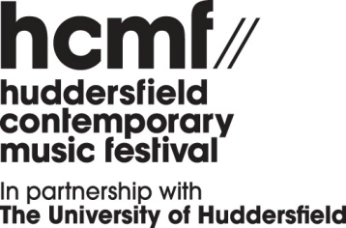

hcmf// shorts 2024

Application Form

Please note:
- Proposed programmes must be no longer than 20 minutes in duration
- All hcmf// shorts performances will take place on Monday 18 November 2024

Please send your completed application form along with:
- A copy of your project proposal (which should be no longer than one side of A4 or 2 minutes for a video proposal)
- Supporting audio material (this should be directly relevant to your proposal)
- A completed monitoring form

Please submit your application by email to info@hcmf.co.uk

Name:
Name of ensemble: (if applicable):

Address:

Postcode:

Phone no:

Email:

Website Links:

Biography (100 words max):

(If applying on behalf of an ensemble, please provide an ensemble biography here)

